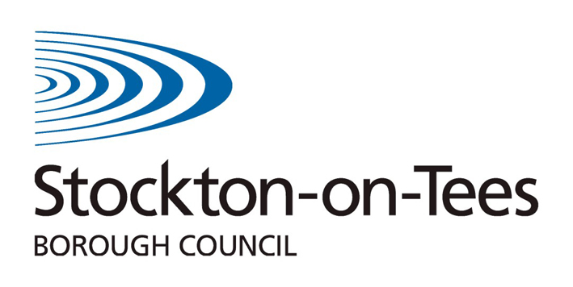
Personal Education Plan

Key Stage 3/4

Young Person's View

Name of Student: | DOB: | Date:

- Do you feel safe in school?

Yes No Why?

- Do you enjoy school?

Yes No Why?

- How do you currently feel when you are at school?

Happy Ok Sad

- How do you currently feel when you are at school?

Happy Ok Sad

- Do you know the levels you have achieved in your subjects?

Yes No Not sure

- How would you rate your progress in the following areas?
 | Excellent | V. Good | Good | Needs attention
Attendance
Behaviour
Effort
Ability to get on with my friends
Ability to get on with adults

- Do you get homework?
Yes No

- How often do you get home learning? (homework)
Every day | 2-3 times per week | 1-2 times per week | None
- Can you manage your homework?

Yes No

- Do you think you need any help in school?
I need help with | Who can help | When

- If you have a problem in school who would you prefer to talk to?

- Do you take part in any activities after school/out of school?

- What are you proud of: this term? This year?

- Next Term/Year my targets/goals are:
- _____________________________________________________________________

- ___________________________________________________________________

- _____________________________________________________________________________

- My aspirations -Long term I would like to:-

- The meeting is about you, is there anything you would like to discuss or bring to the meeting?
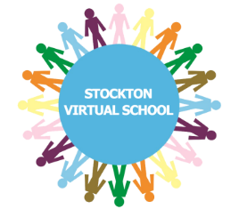

Signed (Student) ___________________________________
Date______________________________________________

