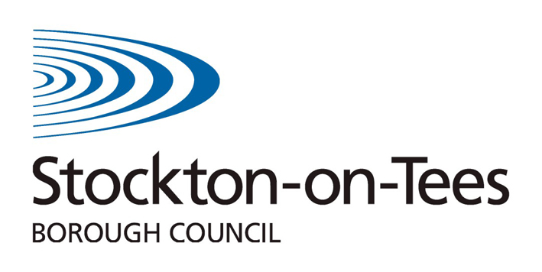
Personal Education Plan

Key Stage 3/4

Young Person's View

Name of Student: | DOB: | Date:

- Do you feel you are a positive member of the school community?

Yes No Why?

- Does your school expect you to work hard and do your best?

Yes No Why?

- How do you currently feel about your progress at school?

Proud Ok Sad

- Do you know the levels you have achieved in your subjects?

Yes No Not sure

- Do you understand what you need to do to reach your target grades/improve your work?

Yes No Why?

- How would you rate your progress in the following areas?
 | Excellent | V. Good | Good | Needs attention
English
Maths
Science
Making a positive contribution
Balancing school work with other interests

- What do you think about your subjects?
My favourite subjects | My least favourite subjects | The subjects I need help with

- Do you know how the Pupil Premium Plus funding is being used to support you?

- Is there something you think the funding could be used for to help you with your learning?

- Is there anything else that would help at school?

- What would you like to achieve by the end of this academic year?

- Do you attend your PEP meetings? Why/why not?

Additional question for Year 9 and above
- Do you feel supported by school to think about your options for Post 16?

- Is there any further help you need with Post 16 planning?

Signed (Student) __________________________________ Date____________

