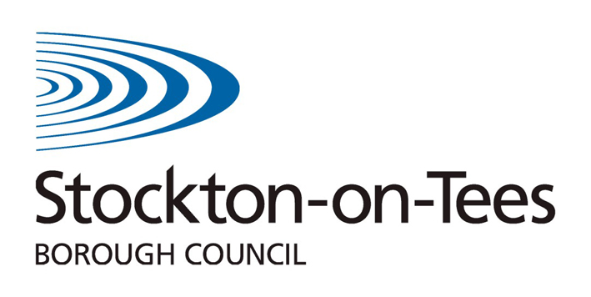
Personal Education Plan

Key Stage 3/4

Young Person's View

Name of Student: | DOB: | Date:

- Have you enjoyed this school year?

Yes No Why?

- Have you taken part in any trips/visits/events with school?

Yes No Why?

- Have you taken part in any school productions/presentations/sporting events?

Yes No Please give details of events

- Have you taken part in any charity/fund raising/community events this year?

Yes No Please give details of events

- Do you attend any after or out of school clubs?

Yes No Please give details

- Have you attended any Secondary Hub events this year?

Yes No

Please give details

If Yes – did you find the session enjoyable/helpful ?
If No – please explain why

- How would you rate your independent living skills?
 | Excellent | V. Good | Good | Needs attention
Making your own food
Travelling independently
Making decisions about how to spend your own money
Making decisions about how to save money
Keeping yourself and your home clean and tidy

- How would you rate your social skills?
 | Excellent | V. Good | Good | Needs attention
Making decisions about how to spend free time
Managing social media and other technology
Staying safe when gaming and online
Maintaining positive friendships and belonging to different groups
Being confident to participate in new experiences/ visit new places

- Have you completed your SDQ questionnaire this year?

- Has someone talked to you about your score?

- Is there any help you need to improve your well being?

- Who listens to your thoughts/views/ideas or worries?

- Do you attend your CYPIOC Review meetings with your IRO? Why/why not?

Additional question for Year 9 and above
- Have you been supported to explore different careers that you might be interested in?

- Do you feel supported by school to think about understanding the options available to you for Post 16?

Signed (Student) __________________________________ Date_____________

